Lab Worksheet 5
Student’s Name
Institutional Affiliation

Lab Worksheet 5
- Describe a circumstance (e.g. in its’ natural environment) where Staphylococcus species bacteria might benefit from being salt tolerant.
When there is very high salt content in the environment, Staphylococcus aureus either lose too much salt from the environment or lose too much water making them hydrate and finally die. This is because a higher concentration of salt in the environment draws water out of the bacteria which would eventually kill them. Given their high resistance to salt concentration in the environment, studies have revealed that the bacteria contain signaling molecules which detect higher concentrations of salt in the environment. In a high salt concentration in the environment, the signaling molecule communicates with transporter proteins that will send signals to the cell for its protection.
- How might the ability to perform hemolysis benefit a hemolytic organism in its’ natural environment?
Hemolytic organisms such as some pathogenic bacteria use this ability to utilize and release nutrients gained from the host cells of the animals. However, the concentration of these nutrients is low outside the cells thus, they manage to tap and use them. For instance, if the bacteria can access free hemoglobin, they can use the iron bound to the heme group of hemoglobin.
- Imagine that you have a culture containing a single bacterial species. This culture may be one of several possible species. Describe a scenario where you use Mannitol Salt agar, Blood Agar, and EMB plates to identify the unknown bacterial species. That is, how would you use these plates to help you identify it?
Mannitol Slat Agar: This test differentiates staphylococcus aureus from other staphylococcus species. The organism is inhibited by NaCl when the outcome is no/poor growth. Thus, the organism is not staphylococcus. When the growth is found to be good, the organism is Staphyloccocus since it is not inhibited by NaCl. The organism produces acid from the fermentation of mannitol if a yellow growth takes place. This signifies a possibility of a pathogenic Staphyloccocus aureus. On account that the red growth lacks a halo; it means that the organism does not ferment mannitol and is, therefore, Staphyloccocus although not S. aureus.
Eosin Methylene Blue Agar: EMB agar is used to detect gram negative bacteria. This test differentiates the lactose fermenting bacteria from the non-lactose fermenting bacteria. The media is streaked and inoculated and incubated for 37°C for a period of 24 hours. The result is determined by the color and number of bacterial growth. Poor or lack of growth signifies eosin or methylene blue inhibits the organism, and thus, it is gram positive. Growth implies that the organism is gram negative given. It is not inhibited by eosin or methylene blue. Should the growth result in a pink color or be mucoid, it means that the organism present ferments lactose and produces very little or no acid (Tsang, 2020). A dark, black or purple growth means the organism ferments lactose to produce and acid and is probably a coliform. However, when the outcome is a pink, green, red, or purple color, the organism is non-coliform and does not ferment lactose.
Blood Agar: Blood agar contains 5-15% horse or sheep blood needed for the growth of the Streptoccocus species (Tsang, 2020). The blood sample is streaked for isolation and incubated at 37°C for 24 hours. When these bacteria break down blood cells during hemolysis, they produce different shapes that can determine the kind of organism present.
This is a test that can be used to differentiate the various organisms present since the selective and differential components will help give the much needed distinction.
- What is the main goal of streaking for isolation?
Streaking is mainly aimed at producing isolated colonies of an organism on the agar plate. Producing such a distinction is important when there is a need to study the morphology and colony of the organism under investigation.
- What happens if you forget to sterilize the loop in between sectors (note – it is not related to contamination)?
There will be a higher likelihood of not diluting the inoculum that is enough to get separate colonies.

- What happens if you transfer from the stock culture to inoculate each of the sectors?
You may not obtain isolated colonies.
- Suppose you successfully streak a plate and obtain isolated colonies of two different bacterial species (that is, a mixed culture)? How can you use this plate to create a new pure culture of only one of the bacteria?
I will use aseptic techniques to sample one of the colonies and use it to inoculate a new sterile medium.
- In the table below are a variety of agar plate media available to microbiologists to cultivate bacteria. Denote whether each medium is non-selective (general growth media), selective, and/or differential by placing an “X” in the appropriate column or columns. (2 points for correctly filling out the entire table).

Type of Agar Plate | Non-selective Media | Selective Media | Differential Media
Nutrient Agar (NA) | X
Tryptic Soy Agar (TSA) | X
TSA with 5% Sheep Blood (BAP) | X |  | X
Chocolate Agar Plate (CAP)
MacConkey (MAC) |  | X | X
Eosin Methylene Blue (EMB) |  | X | X
Hektoen Agar (HE) |  | X | X
Phenyl Ethyl Alcohol (PEA) |  | X
Mannitol Salt Agar (MSA) |  | X | X

- Which agar plate below was inoculated using a streak-plate technique? (A, B or C?):

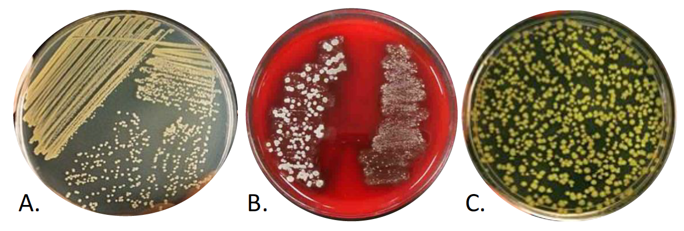
Image A represents the streak-plate technique.
- When performing antibiotic sensitivity testing, it is important that the test conditions are kept very standardized. Why?
The agar used for this kind of test is Mueller-Hinton (15x150mm). The use of this agar ensures that the same organism can produce the zones of inhibition (Student Health Center Manuals, 2019). Besides, it does not inhibit sulfonamides. The depth of the agar should be 4mm to make sure reproducibility and standardization takes place.
References
Student Health Center Manuals. (2019). Kirby Bauer antibiotic sensitivity **. https://shs-manual.ucsc.edu/policy/kirby-bauer-antibiotic-sensitivity
Tsang, J. (2020, February 7). Identifying bacteria through look, growth, stain, and strain. ASM.org. https://asm.org/Articles/2020/February/Identifying-Bacteria-Through-Look,-Growth,-Stain,

